A Comparative Analysis of the Impacts of Sea-Level Rise in Developing Countries

By

Susmita Dasgupta*
Benoit Laplante**
Craig Meisner*
David Wheeler*
and
Jianping Yan**

Draft Report

December 2006

* Development Research Group, World Bank. The views expressed here are the authors’ and do not reflect those of the World Bank, its Executive Directors, or the countries they represent.

** Independent consultants, Canada.

Correspondence should be addressed to: Dr. Susmita Dasgupta, World Bank, 1818 H Street, NW, Washington, DC 20433, sdasgupta@worldbank.org.
I. Introduction

As noted by the International Panel on Climate Change (IPCC, 2001b), climate change may result in a large number of (mostly negative) effects including a greater frequency of heat waves, an increased intensity of storms, floods and droughts, and a more rapid spread of disease, species extinction and loss of biodiversity. These effects also include rising sea levels.

Various models are currently suggesting an increase of the global-mean sea level ranging between 9 and 88 centimeters in the course of the 21st century (Church et al. 2001). Thermal expansion of the ocean is expected to be the dominating factor behind this rise in sea level. Further contributing factors include the deglaciation of Greenland and of Antarctica in particular. If the Greenland ice sheet were to melt completely, it would raise average sea level by approximately 7 meters (Church et al. 2001). Recent research indicates that complete or partial deglaciation may result even with modest atmospheric carbon dioxide stabilization targets (Lowe et al. 2006). Antarctica, the Earth’s fifth largest continent, is covered with an ice sheet containing approximately 25 million km³ of ice. Were it to melt, global sea level would rise by approximately 57 meters (Rapley, 2006).

A particular and increasing concern pertains to the stability of the West Antarctic Ice Sheet (WAIS) which currently rests on bedrock below sea level. Mercer (1978) speculated that human-induced global warming could cause the WAIS to be released into the ocean by a sliding mechanism (also referred to as WAIS’ collapse). This would cause a rapid rise in sea level since it would be triggered solely through a displacement of the WAIS without it having to melt. Were the WAIS to collapse it is expected that it would raise average sea level by approximately 5 to 6 meters.

While there remains considerable uncertainty as to the likelihood of the above scenarios and the time horizon over which they may unfold, recent research suggests that the IPCC projections may be significantly conservative. Indeed, new measurement information on the rates of deglaciation in Greenland and the West Antarctic suggests that the contribution of these two ice sheets is significantly higher than previously known.
Using satellite interferometry observations of Greenland, Ringot and Kanagaratnam (2006) detected widespread glacier acceleration in the lower latitudes of the Greenland Ice Sheet between 1996 and 2000, which rapidly expanded to higher latitudes by 2005. When combined with surface loss estimates by Hanna et al. (2005), they calculate a total loss twice as large as the loss observed in the previous decade. Comparing this rate of contribution of the Greenland ice sheet with that stated in the IPCC report for the 20th century, these new estimates are two to five times larger.

In another study of mass loss for Greenland, Krabill et al. (2004) found that between 1993 and 1994 and again between 1998 and 1999, the ice sheet lost approximately 55 gigatons of ice per year corresponding approximately to a sea level rise of 0.15 mm per year. Despite anomalous excess snowfall in the southeast between 2002 and 2003, net mass loss over the period 1997-2003 was higher than the loss between 1993 and 1999, averaging approximately 75 gigatons of ice per year, or approximately 0.21 mm per year of sea level rise. These rates of sea level rise are roughly double the rate assumed in the IPCC (2001) Third Assessment Report (TAR)

In Antarctica, Velicogna and Wahr (2006) assessed mass variations of the entire Antarctic ice sheet during the period 2002-2005. Using the Gravity Recovery and Climate Experiment (GRACE) satellites, their results indicate that the mass of the ice sheet decreased significantly, at a rate of approximately 152 cubic kilometers of ice per year, which is equivalent to 0.4 mm per year in terms of global sea level rise. This rate is numerous times greater than that assumed in TAR. The IPCC did in fact recognize that the final value adopted in TAR did not take into account the dynamic changes in the WAIS.

Hence, despite the remaining uncertainty, recent research and expert opinions indicate that significant sea-level rise may result earlier than previously thought. This has prompted a number of researchers to model the estimated impact of significant increases in sea-level rise (occasionally referred to as ‘extreme climate scenarios’). A number of studies have provided estimates of the potential impacts of various sea-level rise scenarios for specific individual developed countries (e.g. France, the Netherlands, Poland, Singapore and the United States), and developing countries (e.g. Bangladesh, Benin, China, Nigeria, and Senegal) or specific areas of individual countries (e.g. deltas of the Nile and Bengal; Rhine Delta, Thames Estuary and Rhone Delta). Only a limited number of studies have attempted to assess the impacts of sea-level rise on a broader regional or world wide scale. Such studies include: Darwin and Tol (1999), Hoozemans et al. (1993), Nicholls and Mimura (1998), Nicholls et al. (2004), Nicholls and Lowe (2006), and Nicholls and Tol (2006). A number of these studies examine the impact of ‘extreme climate scenarios’ such as a 5 meter sea level rise (e.g. Nicholls et al., 2004). However, while indicators of impacts generally include land loss, population affected, capital loss value, and wetlands loss, different studies have used different subsets of indicators or regions, making a comparison of relative magnitude of impacts across countries or regions difficult.

To our knowledge, no study has attempted to assess systematically the impacts of sea-level rise individually for all developing countries of the world using a homogeneous set of indicators, and for a multiplicity of sea-level rise scenarios. Mendelsohn et al. (2006) is closer in scope to the study presented in this paper in that it examines the market impacts of climate change on rich and poor countries for a number of different climate scenarios. Their estimates reveal that poor countries will suffer most of the damages from climate change. While this study is of great interest and significance, it does not focus explicitly on examining the impact of sea level rise on a multiplicity of physical and economic indicators. We report in this paper the results from such a research effort.

For the purpose of this study, 84 developing countries of the world (with coast lines) were grouped into 5 regions (corresponding to the 5 regional departments of the World Bank): Latin America and Caribbean Region (25 countries); Middle East and North Africa Region (13 countries); Sub-Saharan Africa (29 countries); East Asia (13 countries); and South Asia (4 countries). For each of these countries and regions, we assess the impact of sea-level rise using the following 6 indicators: land, population, gross domestic product (GDP), urban extent, agricultural extent, and wetlands. Finally, these impacts are calculated for sea-level rise scenarios ranging from 1 to 5 meters.

At the outset, it shall be understood that any global analysis of this nature is an ambitious initiative and has its own limitations. In particular, in this report we do not assess the likelihood of the above sea level rise (SLR) scenarios. As most other studies of this nature have done, we take as given the above SLR scenarios, and for each of these scenarios provide an assessment of the impacts of SLR based on the 6 indicators for each of the 84 developing countries and 5 regions as mentioned above. Perhaps more importantly, we assess the impacts of SLR on population, socio-economic and land use conditions as these conditions currently prevail. Hence, unlike a number of previous studies (albeit not all), we do not attempt in this paper to predict population and economic growth rates or potential changes in land use for a large number of decades in the future for each of the countries included in this study, and then assess the impact of a slowly increasing sea level against those baseline projections. The scenario retained in this analysis leads us generally to underestimate the impacts of SLR. This underestimation is obviously significant when the impact of SLR on population and GDP are measured in absolute terms (number of people impacted or $ of GDP impacted), However, it is not expected to be very significant when these impacts are measured in percentage terms since the extent of the underestimation then results solely from the fact that coastal population and urban centers are generally growing at a faster rate than national averages, and wetlands and agricultural extent are already under pressure. Finally, it shall be noted that the implications of sea level rise (even if happening over many decades or centuries) are not only long-term in nature. Even small changes in sea level rise can have a profound implication on the impact of storm surges, which generally occur annually and often have devastating, albeit relatively short-term, consequences on coastal areas. Sea level rise basically acts as the baseline reference point to which storm surge height is added.

Despite these limitations, we believe that the existing study provides a comprehensive baseline of the relative impacts associated with sea-level rise against which policy-makers of these countries as well as international development institutions may better be able to assess and allocate resources devoted to mitigation and adaptation. In particular, we believe that by assessing (and underestimating) the impact of sea-level rise on existing physical and socio-economic conditions is more likely to trigger the development of short, medium, and long term plans aimed at reducing or minimizing the impact of sea-level rise. Finally, it shall be noted that the implications of sea level rise (even if happening over many decades or centuries) are not only long-term in nature. Even small changes in sea level rise can have a profound implication on the impact of storm surges, which generally occur annually and often have devastating, albeit relatively short-term, consequences on coastal areas. Sea level rise basically acts as the baseline reference point to which storm surge height is added.

In the next section, we describe the methodology and data sources used to estimate the impact of sea level rise in developing countries. Results are presented in Section III first at the global level, and then at the level of each of the 5 regions. The above 6 indicators are further presented individually for each country comprising each of the 5 regions.

We briefly conclude in Section IV.

II. Methodology and data sources

II.1 Data Sources

To achieve the objective stated above, we employed geographic information system (GIS) to overlay the critical exposure elements (land, population, agriculture, urban extent, wetlands, and GDP) with the derived potential inundation zones, and estimated measures of potential impact for regions, countries and localities.

The project collected the best available, spatially-disaggregated data sets from various public sources, including the Center for Environmental Systems Research (CESR), the
Center for International Earth Science Information Network (CIESIN), the International Centre for Tropical Agriculture (CIAT), the International Food Policy Research Institute (IFPRI), the National Aeronautics and Space Administration (NASA), the National Oceanographic and Atmospheric Administration (NOAA), and the World Bank. Table 1 summarizes the data sources for inundation zoning and exposure assessment.

Table 1
Summary of Data Sources

Dimension | Dataset  Name | Unit | Resolution | Source(s)
Coastline and country boundary | WVS |  | 1:250,000 | NOAA/NASA
Elevation | SRTM 90m DEM V2 | km² | 90m | CIAT
Population | GPW-3 | Population counts | 1km | CIESIN
Economic activity | GDP2000 | million US dollar | 5km | World Bank based on Sachs et al. (2001)
Urban extent | GRUMP V1 | km² | 1km | CIESIN
Agricultural extent | GAE-2 | km² | 1km | IFPRI
Wetland | GLWD-3 | km² | 1km | CESR, Lehner, B. and Döll, P. (2004)

II.2 Methodology

The country indicator database was developed by following a six-step working procedure briefly described below.

Step 1 Preparing country boundary and coastline
Country coastlines were built by sub-setting polygons from the World Vector Shoreline (polygon), a standard National Geospatial Intelligence Agency (formerly Defense Mapping Agency) product at a nominal scale of 1:250,000. It contains worldwide coverage of shorelines and international boundaries. The subset country coastlines were also used as a mask for calculating country totals for the selected exposure indicators.

Step 2 Building coastal terrain models (DTM)
Coastal terrain models were derived from the CIAT SRTM 90 meters digital elevation model (DEM) data (Version 2) released in 2005. Zipped data files were downloaded from the CIAT website, and then converted into raster format, and mosaiced in terms of country boundary in the ArcGIS environment.
Step 3 Identifying potential inundation zone
Potential inundation zones were derived from the coastal terrain model (DTM) by setting the value of pixels in the DTM to 1 in terms of the different scenarios of sea level rise examined in this study. Pixels that are apparently not connected to coastlines, such as inland wetlands and lakes, were masked out manually.

Step 4 Calculating exposure indicators
Estimates for each indicator were calculated by overlaying the potential inundation zone with the appropriate exposure surface datasets (land area, GDP, population, urban extent, agriculture extent, and wetland). Exposure surface data were collected from various public sources. Unless otherwise indicated, latitude and longitude are specified in decimal degrees. The horizontal datum used is the World Geodetic System 1984 (WGS 1984). For area calculation, all units are projected to World Equal Area.

In terms of the nature of the exposure grid surfaces, two GIS models were built for calculating the exposed value. Because the values of the pixels in GDP and population surfaces are respectively in millions of US dollars and number of people, the exposure is calculated by multiplying the exposure surface with the potential inundation zone and then summing up by multiplying grid count and value. Exposure indicators, such as land surface, urban extent, agriculture extent and wetland are measured in square kilometer.

Step 5 Adjusting absolute exposure indicators

For exposure indicators such as land area, population and GDP, which have measured country totals available, the exposed value is adjusted to reflect its real value by using the following formula:

$V_{\text{adj}}=\frac{{\text{CT}}_{\text{mea}}}{{\text{CT}}_{\text{cal}}}⋅V_{\text{cal}}$

where

V_{adj} – Exposed value adjusted;

V_{cal} – Exposed value calculated from exposure grid surfaces;

CT_{mea} – Country total obtained based on statistics;

CT_{cal} – Country total calculated from exposure grid surface.

Step 6 Conducting data quality assurance and control
Quality assurance and control was conducted to examine the errors that may be caused by overlaying the grid surfaces of different resolutions, such as 90 meter resolution inundation zone with 1 kilometer or 5 kilometer exposure grid surfaces. In this study, the cross-check was conducted as the following procedure:

- Calculate the country total from the grid surface using country boundary;
- Calculate the aspect exposure that is under 5 meter sea level;
- Calculate the aspect exposure that is over 5 meter sea level;
- Compare the country total with the sum of both aspect exposures. If the difference is less that 5%, the calculated aspect exposure was considered within the error tolerance. If not, the exposure calculation was reviewed and estimates revised until the 5% difference threshold was reached.

A more detailed description of each of the above datasets is provided in Appendix 1.

III. Results

In this section we present the results of the analysis. In the first sub-section below, we present results at the global level (for the 84 developing countries included in this analysis). In sub-section III.2, we present the results for each of the 5 regions and individually for each of the 84 countries. It will be shown that for a number of countries, sea-level rise, even if limited to 1 meter, would have a very significant impact.

III.1 Global results

As shown in Table 2, approximately 0.3% (194 thousands km²) of the territory of the 84 developing countries included in this study would be impacted by a 1 meter sea level rise (SLR). This would increase to 1.2% under a 5m SLR scenario. Though this remains relatively small in percentage terms, approximately 56 million people (or 1.28% of the population) of these countries would be impacted under a 1m SLR scenario. This would increase quickly to 89 million people under a 2m SLR (2.03%) and reach 245 million people (5.57%) under a 5m SLR. The impact of SLR on GDP is slightly larger than the impact on population. This indicates and is consistent with the fact that coastal populations and cities generally benefit from a higher GDP per capita than national averages. Wetlands would experience significant impact even under a modest 1m SLR. Up to 7.3% of the wetlands of these 84 countries would be impacted by a 5m SLR.

As shown in the next section, these impacts do not distribute uniformally across the various regions and developing countries of the world. In particular, the impacts are very severe on a limited number of countries.

Table 2
Impacts of sea level rise: Global level

 | 1m | 2m | 3m | 4m | 5m
Area (Total = 63,332,530 sq. km.)
Impacted area | 194,309 | 305,036 | 449,428 | 608,239 | 768,804
% of total area | 0.31 | 0.48 | 0.71 | 0.96 | 1.21
Population (Total = 4,414,030,000)
Impacted population | 56,344,110 | 89,640,441 | 133,049,836 | 183,467,312 | 245,904,401
% of total population | 1.28 | 2.03 | 3.01 | 4.16 | 5.57
GDP (Total = 16,890,948 million USD)
Impacted GDP (USD) | 219,181 | 357,401 | 541,744 | 789,569 | 1,022,349
% of total GDP | 1.30 | 2.12 | 3.21 | 4.67 | 6.05
Urban extent (Total = 1,434,712 sq. km.)
Impacted area | 14,646 | 23,497 | 35,794 | 50,742 | 67,140
% of total area | 1.02 | 1.64 | 2.49 | 3.54 | 4.68
Agricultural extent (Total = 17,975,807 sq. km.)
Impacted area | 70,671 | 124,247 | 196,834 | 285,172 | 377,930
% of total area | 0.39 | 0.69 | 1.09 | 1.59 | 2.10
Wetlands area (Total = 4,744,149 sq. km.)
Impacted area | 88,224 | 140,355 | 205,697 | 283,009 | 347,400
% of total area | 1.86 | 2.96 | 4.34 | 5.97 | 7.32

III.2 Regional results

In this sub-section, we examine results for each of the following 5 regions: Latin America and Caribbean, Middle East and North Africa, Sub-Saharan Africa, East Asia, and South Asia. For each of these regions, country specific results are also presented and discussed. To facilitate the reading of these results, we follow a similar structure of presentation for all regions.

(i) Latin America and Caribbean region

As shown in Table 3, the impact of SLR in Latin America & Caribbean region is relatively similar to the impact noted earlier for all developing countries insofar as land area, agriculture and wetlands are concerned. However, a much smaller percentage of the region’s population and GDP would be impacted (0.57% and 0.54% respectively in the region for 1m SLR scenario vs. 1.28% and 1.30% respectively worldwide). The same also holds for the impact on urban infrastructure.

Table 3
Impacts of sea level rise:
Latin America & Caribbean region

 | 1m | 2m | 3m | 4m | 5m
Area (Total = 18,806,598 sq. km.)
Impacted area | 64,632 | 101,736 | 149,183 | 193,786 | 234,117
% of total area | 0.34 | 0.54 | 0.79 | 1.03 | 1.24
Population (Total = 501,550,000)
Impacted population | 2,873,505 | 4,732,734 | 7,247,905 | 10,268,489 | 13,472,827
% of total population | 0.57 | 0.94 | 1.45 | 2.05 | 2.69
GDP (Total = 3,649,731 million USD)
Impacted GDP (USD) | 19,663 | 36,201 | 49,447 | 67,403 | 86,850
% of total GDP | 0.54 | 0.99 | 1.35 | 1.85 | 2.38
Urban extent (Total = 505,477 sq. km.)
Impacted area | 3,080 | 5,212 | 8,090 | 11,614 | 15,294
% of total area | 0.61 | 1.03 | 1.60 | 2.30 | 3.03
Agricultural extent (Total = 4,889,156 sq. km.)
Impacted area | 16,104 | 29,514 | 47,003 | 66,330 | 85,959
% of total area | 0.33 | 0.60 | 0.96 | 1.36 | 1.76
Wetlands area (Total = 1,651,735 sq. km.)
Impacted area | 22,314 | 38,782 | 60,876 | 85,734 | 108,476
% of total area | 1.35 | 2.35 | 3.69 | 5.19 | 6.57

When examined at the country level, one notes very significant differences across countries of the region. As is starkly revealed in Figure 2, the Bahamas would experience the largest percentage of impacted land: Even with a 1m SLR, approximately 11% of the land area of the Bahamas would be impacted. This percentage reaches in excess of 60% under a 5m SLR scenario. Cuba and Belize would also experience significant impact, albeit at a much reduced scale when compared with the Bahamas.

Figure 2
Latin America & Caribbean: Country area impacted

Figure 3a and 3b show the impact of SLR on population. With a 1m SLR, the population of Suriname, Guyana, French Guiana, and the Bahamas would be most severely impacted (as a percentage of national population): 7%, 6.3%, 5.4% and 4.5% respectively. These percentages increase rapidly to reach 30% in Suriname and 25% in Guyana for a 3m SLR. Approximately half of the population of these countries would be impacted with a 5m SLR.

In terms of economic activity (Figure 4a), the impact of a 1m SLR on Suriname, Guyana, and the Bahamas’ GDP is expected to reach approximately 5%. With a 3m SLR, impacted GDP reaches 20% in Suriname, and approximately 15% in both Guyana and Bahamas. Guyana would however exhibit the largest percentage of urban extent impacted (Figure 4b). It reaches 10% with a 1m SLR, and increases rapidly to 22% and 38% with a 2m and 3m SLR.

Figure 3a
Latin America & Caribbean region: Exposed population (5m SLR)

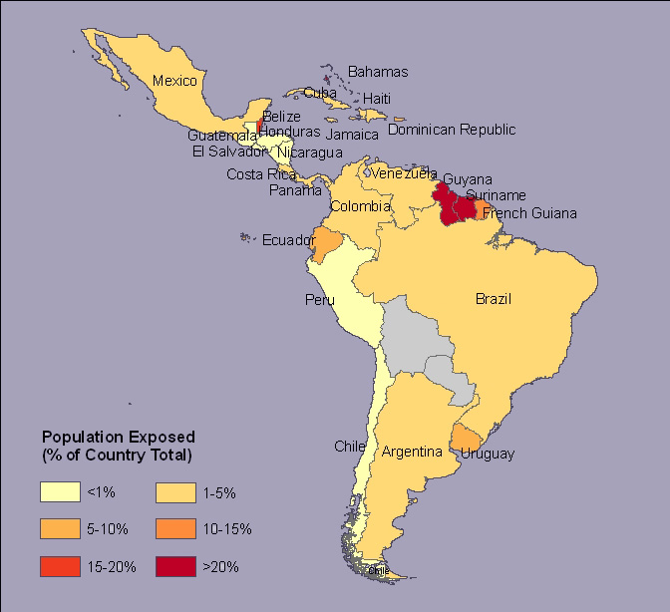

Figure 3b
Latin America & Caribbean: Population impacted

Figure 4a
Latin America & Caribbean: GDP impacted

Figure 4b
Latin America & Caribbean: Urban extent impacted

Bahamas’ agricultural extent exhibits the highest impact (Figure 4c). It is of interest to note that while area, population and GDP would indicate Argentina not being significantly impacted by SLR, its agricultural extent would however be significantly impacted.

Finally, this analysis reveals that wetlands of the region would be severely impacted by SLR (Figure 4d). With a 1m SLR, approximately 30% of Jamaica and Belize’s wetlands would be impacted. With a 5m SLR, most of the Bahamas and Belize wetlands would be impacted as well as more than half of Cuba’s wetlands.

Figure 4c
Latin America & Caribbean: Agricultural extent impacted

Figure 4d
Latin America & Caribbean: Wetlands impacted

(ii) Middle East and North Africa region

When compared with worldwide results presented earlier, Table 4 reveals that while the land (country area) of the Middle East and North Africa region would be less impacted by SLR (0.25% vs. 0.31% with a 1m SLR), all other indicators suggest more severe impacts of SLR in this region than otherwise in the world. In particular, with a 1m SLR, 3.2% of the population of this region would be impacted (vs. 1.28% worldwide), 1.49% of its GDP (vs. 1.30% worldwide), 1.94% of its urban population (vs. 1.02% worldwide), and 3.32% of its wetlands (vs. 1.86% worldwide). Except for country area, the impacts of SLR are much more severe in this region than in the Latin America and Caribbean region.

Table 4
Impacts of sea level rise:
Middle East and North Africa region

 | 1m | 2m | 3m | 4m | 5m
Area (Total = 10,050,556 sq. km.)
Impacted area | 24,654 | 33,864 | 43,727 | 53,615 | 63,120
% of total area | 0.25 | 0.34 | 0.44 | 0.53 | 0.63
Population (Total = 259,396,000)
Impacted population | 8,307,472 | 10,912,744 | 13,684,993 | 16,454,655 | 19,439,678
% of total population | 3.20 | 4.21 | 5.28 | 6.34 | 7.49
GDP (Total = 1,404,470 million USD)
Impacted GDP (USD) | 20,870 | 30,365 | 39,037 | 46,209 | 54,853
% of total GDP | 1.49 | 2.16 | 2.78 | 3.29 | 3.91
Urban extent (Total = 190,030 sq. km.)
Impacted area | 3,679 | 5,037 | 6,529 | 7,951 | 9,384
% of total area | 1.94 | 2.65 | 3.44 | 4.18 | 4.94
Agricultural extent (Total = 354,294 sq. km.)
Impacted area | 4,086 | 6,031 | 8,007 | 9,819 | 11,451
% of total area | 1.15 | 1.70 | 2.26 | 2.77 | 3.23
Wetlands area (Total = 342,185 sq. km.)
Impacted area | 11,361 | 14,758 | 18,224 | 21,417 | 24,277
% of total area | 3.32 | 4.31 | 5.33 | 6.26 | 7.09

When examined at the country level, only Qatar’s land area would experience a significant impact (Figure 5).
Figure 5
Middle East and North Africa region: Country area impacted

Of all countries of the region, Egypt’s population would be most severely impacted by SLR. With a 1m SLR, approximately 10% of Egypt’s population would be impacted. Most of this impact takes place in the Nile Delta. This percentage then increases only slowly to reach 20% with a 5m SLR. Approximately 5% of the population of United Arab Emirates and Tunisia would also be impacted by a 1m SLR. Egypt’s GDP would also be significantly impacted by SLR (Figure 7a). This is partly explains by the impact of SLR on Egypt’s agricultural extent. Indeed, most of the impact of SLR on the agricultural sector of the region would take place in Egypt which would experience a severe impact (Figure 7c). Even with a 1m SLR, approximately 12.5% of Egypt’s agricultural extent would be impacted; this percentage reaches 35% with a 5m SLR. Egypt’s agricultural sector may thus experience severe disruption as a result of SLR.

Figure 6a
Middle East and North Africa region: Exposed population (5m SLR)

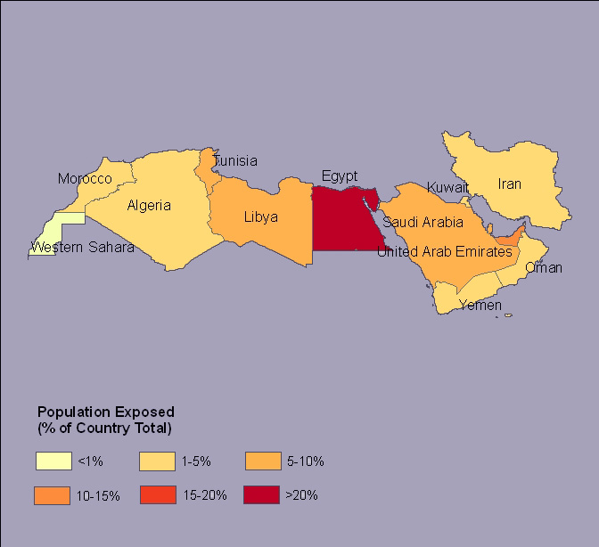

Figure 6b
Middle East and North Africa region: Population impacted

Figure 7a
Middle East and North Africa: GDP impacted

Urban extent of the region would be significantly impacted. In Egypt, Libya, United Arab Emirates, and Tunisia, the impact reaches approximately 5% with a 1m SLR, 6 to 7% with a 2m SLR, and approximately 10% with a 5m SLR. The wetlands of Qatar, and to a lesser extent Kuwait, Libya, and United Arab Emirates would be significantly impacted by SLR.

Figure 7b
Middle East and North Africa: Urban extent impacted

Figure 7c
Middle East and North Africa: Agricultural extent impacted

Figure 7d
Middle East and North Africa: Wetlands impacted

(iii) Sub-Saharan Africa

At a regional level, the impacts of SLR would remain modest in Sub-Saharan Africa. In fact, of all regions of the world, it is where the impacts are the least significant. As indicated in Table 5, less than ¼ of 1% of the region’s GDP would be impacted by a 1m SLR, while its agricultural extent would remain by and large free of any impact. Only a very small percentage of the region’s area and agricultural extent would be impacted even with a 5m SLR, and less than 1% of the population would be impacted with a 3m SLR.

Table 5
Impacts of sea level rise:
Sub-Saharan Africa

 | 1m | 2m | 3m | 4m | 5m
Area (Total = 16,137,438 sq. km.)
Impacted area | 18,641 | 28,083 | 42,645 | 59,661 | 77,253
% of total area | 0.12 | 0.17 | 0.26 | 0.37 | 0.48
Population (Total = 463,121,000)
Impacted population | 2,098,795 | 3,651,629 | 4,303,289 | 8,471,790 | 11,040,978
% of total population | 0.45 | 0.79 | 0.93 | 1.83 | 2.38
GDP (Total = 963,974 million USD)
Impacted GDP (USD) | 2,228 | 4,368 | 7,143 | 10,897 | 13,722
% of total GDP | 0.23 | 0.45 | 0.74 | 1.13 | 1.42
Urban extent (Total = 109,372 sq. km.)
Impacted area | 430 | 742 | 1,268 | 1,853 | 2,449
% of total area | 0.39 | 0.68 | 1.16 | 1.69 | 2.24
Agricultural extent (Total = 4,236,159 sq. km.)
Impacted area | 1,646 | 3,404 | 6,595 | 11,231 | 16,145
% of total area | 0.04 | 0.08 | 0.16 | 0.27 | 0.38
Wetlands area (Total = 805,030 sq. km.)
Impacted area | 8,902 | 13,551 | 20,625 | 29,078 | 37,864
% of total area | 1.11 | 1.68 | 2.56 | 3.61 | 4.70

At the country level, Gambia’s and to a lesser extent Guinea-Bissau’s country area are those in Sub-Saharan Africa which would be most impacted by SLR (Figure 8). However, even in these two countries, the impact would remain well below 4% even with a 2m SLR, and never raises above 10% except for Gambia with a 4m SLR.

Figure 8
Sub-Saharan Africa: Country area impacted

In terms of population impacted, both Gambia and Mauritania would experience significant impact (Figure 9a and 9b). This impact reaches approximately 8% in Mauritania with a 1m SLR. For most countries, population impacted remains below 5% of the total population even with a 5m SLR. Mauritania’s GDP would also experience the largest impact reaching slightly below 10% with a 1m SLR (Figure 10a). Note that approximately 5% of Benin’s GDP would also be impacted by a 1m SLR. Urban extent is mostly impacted in Mauritania (Figure 10b), while agricultural extent is mostly impacted in Gambia, Guinea-Bissau, and Mauritania (Figure 10c). Approximately 15% of Benin’s wetlands would be impacted by a 1m SLR (Figure 10d). When SLR reaches 5m, Gambia’s and Senegal’s wetlands are those mostly affected.

Figure 9a
Sub-Saharan Africa: Exposed population (5m SLR)

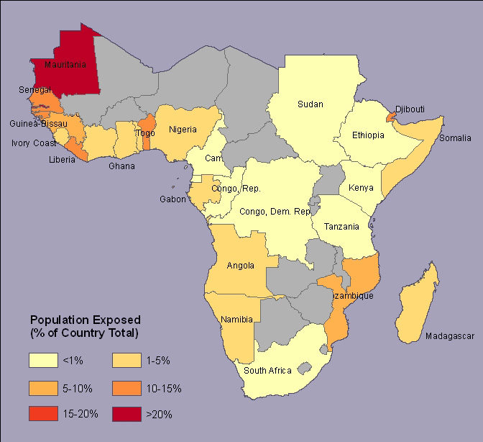

Figure 9b
Sub-Saharan Africa: Population impacted

Figure 10a
Sub-Saharan Africa: GDP impacted

Figure 10b
Sub-Saharan Africa: Urban extent impacted

Figure 10c
Sub-Saharan Africa: Agricultural extent impacted

Figure 10d
Sub-Saharan Africa: Wetlands impacted

(iv) East Asia

As for the Middle East and North Africa region, East Asia would be significantly impacted by SLR. When reaching 5m, East Asia is the most severely impacted region of the world. Impacted population range from 2% to 8.6%, while impacted GDP goes from 2.09% to 10.2%, from 1m to 5m SLR. Urban extent as well as wetlands are also significantly impacted by SLR.

Table 6
Impacts of sea level rise:
East Asia

 | 1m | 2m | 3m | 4m | 5m
Area (Total = 14,140,767 sq. km.)
Impacted area | 74,020 | 119,370 | 178,177 | 248,970 | 325,089
% of total area | 0.52 | 0.84 | 1.26 | 1.76 | 2.30
Population (Total = 1,883,407,000)
Impacted population | 37,193,866 | 60,155,640 | 90,003,580 | 126,207,275 | 162,445,397
% of total population | 1.97 | 3.19 | 4.78 | 6.70 | 8.63
GDP (Total = 7,577,206 million USD)
Impacted GDP (USD) | 158,399 | 255,510 | 394,081 | 592,598 | 772,904
% of total GDP | 2.09 | 3.37 | 5.20 | 7.82 | 10.20
Urban extent (Total = 388,054 sq. km.)
Impacted area | 6,648 | 11,127 | 17,596 | 25,725 | 34,896
% of total area | 1.71 | 2.87 | 4.53 | 6.63 | 8.99
Agricultural extent (Total = 5,472,581 sq. km.)
Impacted area | 45,393 | 78,347 | 121,728 | 174,076 | 229,185
% of total area | 0.83 | 1.43 | 2.22 | 3.18 | 4.19
Wetlands area (Total = 1,366,069 sq. km.)
Impacted area | 36,463 | 56,579 | 79,984 | 110,671 | 130,780
% of total area | 2.67 | 4.14 | 5.86 | 8.10 | 9.57

As shown in Figure 11a, Viet Nam is the most seriously impacted by SLR: Up to 16% of Viet Nam’s country area would be impacted by a 5m SLR. After the Bahamas, Viet Nam’s land area would be the most significantly impacted developing country by SLR. Most of this impact is taking place in the Mekong River Delta, and the Red River Delta. Note in Figure 11b that most of Viet Nam’s land area Southwest of Ho Chi Minh City would be severely impacted by SLR.

A large percentage of Viet Nam’s population and economic activity is located and taking place in these two river deltas. As shown in Figure 12a and 12b, 10.8% of Viet Nam’s population would be impacted by a 1m SLR. This is the largest percentage of impacted population of all 84 developing countries included in this analysis (Egypt follows with 10.56%). Viet Nam’s impacted population would reach 35% with a 5m SLR. The impact of SLR on Viet Nam’s GDP (Figure 13a) and urban extent (Figure 13b) follows closely the impact on its population.

Figure 11a
East Asia: Country area impacted

Figure 11b
Inundation zone: Viet Nam

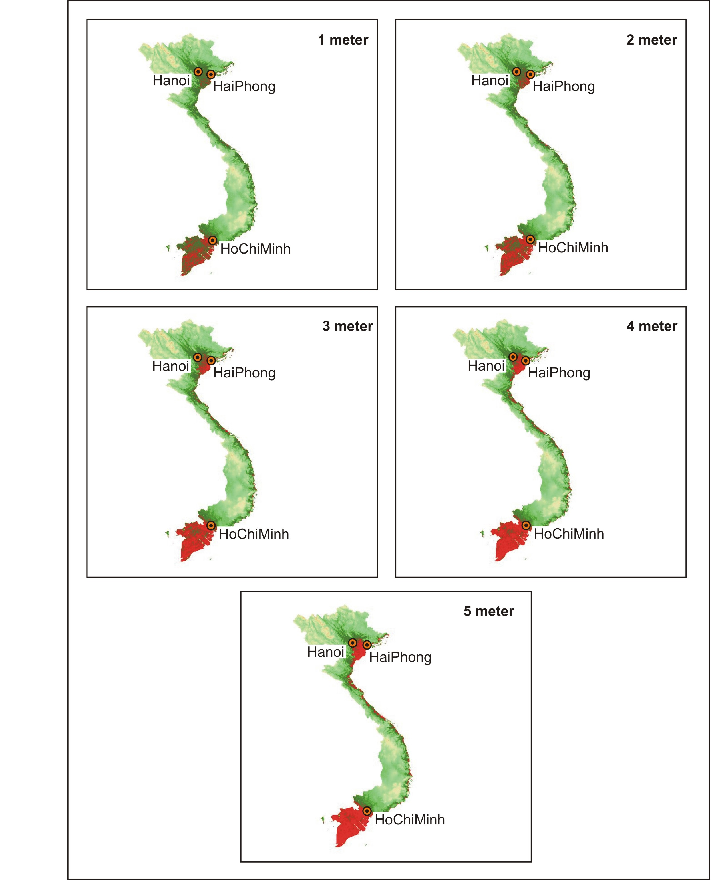

Figure 12a
East Asia: Exposed population (5m SLR)

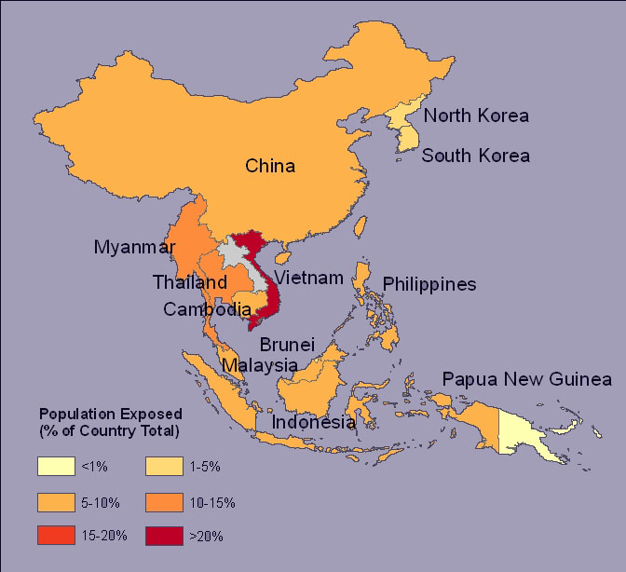

Figure 12b
East Asia: Population impacted

Thailand’s GDP would also experience a significant impact. However, as shown in Figure 13a, this impact would be significant only under a 4m SLR. As for all other indicators, Viet Nam’s agricultural extent would be the most severely impacted in East Asia (Figure 13c). Note that Myanmar’s agricultural extent, as well as wetlands (Figure 13d) would also be significantly impacted. Most, if not almost all of Viet Nam’s wetlands would be impacted by SLR.
Figure 13a

East Asia: GDP impacted

Figure 13b
East Asia: Urban extent impacted

Figure 13c
East Asia: Agricultural extent impacted

Figure 13d
East Asia: Wetlands impacted

(v) South Asia

For a 1m SLR, the impacts of SLR in South Asia mimics those noted in Sub-Saharan Africa, albeit slightly higher. Except for land area, the impacts of SLR in South Asia are smaller than worldwide impacts.

Table 7
Impacts of sea level rise:
South Asia

 | 1m | 2m | 3m | 4m | 5m
Area (Total = 4,197,171 sq. km.)
Impacted area | 12,362 | 21,983 | 35,696 | 52,207 | 69,225
% of total area | 0.29 | 0.52 | 0.85 | 1.24 | 1.65
Population (Total = 1,306,556,000)
Impacted population | 5,870,472 | 10,187,694 | 17,810,069 | 22,065,103 | 39,505,521
% of total population | 0.45 | 0.78 | 1.36 | 1.69 | 3.02
GDP (Total = 3,295,567 million USD)
Impacted GDP (USD) | 18,021 | 30,957 | 52,036 | 72,462 | 94,020
% of total GDP | 0.55 | 0.94 | 1.58 | 2.20 | 2.85
Urban extent (Total = 241,779 sq. km.)
Impacted area | 809 | 1,379 | 2,311 | 3,599 | 5,117
% of total area | 0.33 | 0.57 | 0.96 | 1.49 | 2.12
Agricultural extent (Total = 3,023,617 sq. km.)
Impacted area | 3,442 | 6,951 | 13,501 | 23,716 | 35,190
% of total area | 0.11 | 0.23 | 0.45 | 0.78 | 1.16
Wetlands area (Total = 579,130 sq. km.)
Impacted area | 9,184 | 16,685 | 25,988 | 36,109 | 46,003
% of total area | 1.59 | 2.88 | 4.49 | 6.24 | 7.94

Within South Asia, Bangladesh would experience the largest percentage share of land area impact (Figure 14). However, this impact exceeds 5% only when SLR reaches in excess of 3m. With a 1m SLR, Bangladesh and Sri Lanka’s population experience a similar percentage impact (Figure 15a and 15b). However, as sea level rises, the impact on Bangladesh’s population becomes more important. A similar situation prevails for the impact on these two countries’ GDP.

Figure 14
South Asia: Country area impacted

However, Sri Lanka’s urban extent would experience a slightly larger impact than Bangladesh’s (Figure 16b), while Bangladesh’s agricultural extent would experience a much larger impact than any other South Asian countries (Figure 16c). Insofar as wetlands are concerned (Figure 16d), Pakistan wetland’s would experience the largest impact in South Asia.

Figure 15a
South Asia: Exposed population (5m SLR)

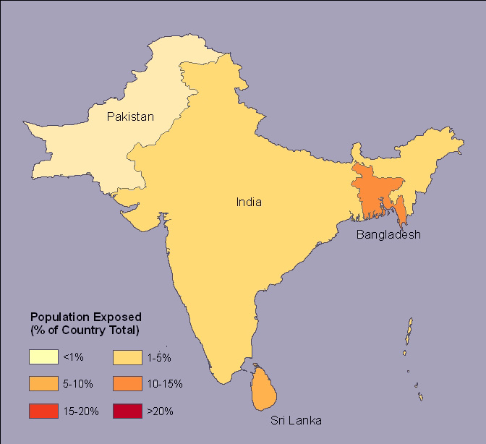

Figure 15b
East Asia: Population impacted

Figure 16a
Sub-Saharan Africa: GDP impacted

Figure 16b
Sub-Saharan Africa: Urban extent impacted

Figure 16c
Sub-Saharan Africa: Agricultural extent impacted
Figure 16d
South Asia Africa: Wetlands impacted

III.3 Summary of results

We briefly summarize the results in this section beginning with a summary of world and regional results. We then summarize our results for each of the 6 indicators used in this analysis by presenting the most (top 10) impacted countries (as a percentage of national parameters).

(i) World and regional results

As shown in Table 8, East Asia and the Middle East and North Africa region would experience the largest percentage impacts resulting from SLR. Population impact is larger in the latter for a 1m SLR, but larger in East Asia for a 5m SLR. A similar scenario holds for the impact on urban extent, agricultural extent, and wetlands. Impact on GDP is much larger in East Asia than in any other regions of the world, reaching 10.2% with a 5m SLR.

Table 8
Summary of world and regional impacts

 | World | LA | MENA | SSA | EA | SA
Indicators
 | 1m SLR
Area | 0.31 | 0.34 | 0.25 | 0.12 | 0.52 | 0.29
Population | 1.28 | 0.57 | 3.2 | 0.45 | 1.97 | 0.45
GDP | 1.3 | 0.54 | 1.49 | 0.23 | 2.09 | 0.55
Urban extent | 1.02 | 0.61 | 1.94 | 0.39 | 1.71 | 0.33
Ag. extent | 0.39 | 0.33 | 1.15 | 0.04 | 0.83 | 0.11
Wetlands | 1.86 | 1.35 | 3.32 | 1.11 | 2.67 | 1.59
 | 5m SLR
Area | 1.21 | 1.24 | 0.63 | 0.48 | 2.3 | 1.65
Population | 5.57 | 2.69 | 7.49 | 2.38 | 8.63 | 3.02
GDP | 6.05 | 2.38 | 3.91 | 1.42 | 10.2 | 2.85
Urban extent | 4.68 | 3.03 | 4.94 | 2.24 | 8.99 | 2.72
Ag. extent | 2.1 | 1.76 | 3.23 | 0.38 | 4.19 | 1.16
Wetlands | 7.3 | 6.57 | 7.09 | 4.7 | 9.57 | 7.94
LA: Latin America and Caribbean; MENA: Middle East and North Africa; SSA: Sub-Saharan Africa; EA: East Asia; SA: South Asia.

(ii) Most impacted countries

Figure 17a to 17e summarize our results for each indicator by ranking the most (top 10) impacted countries (as a percentage of their national values) for each indicator used in this paper. For this purpose, we use the 1m SLR scenario. In terms of land area (Figure 17a), the Bahamas is by far the most impacted country with close to 12% of its land area being affected. In excess of 10% of Viet Nam and Egypt’s population would be impacted with a 1m SLR (Figure 17b). Viet Nam would also see 10% of its GDP (Figure 17c) and urban extent impacted (Figure 17d). Mauritania’s GDP would also be significantly impacted. Egypt’s agricultural extent would experience the largest percentage impact, reaching approximately 14%. Finally, 60% of the Dominican Republic’s wetlands would be impacted by a 1m SLR. For all indicators used in this paper, Egypt and Viet Nam rank among the top 5 most impacted countries.

Figure 17a
Most impacted countries: Land area

Figure 17b
Most impacted countries: Population

Figure 17c
Most impacted countries: GDP

Figure 17d
Most impacted countries: Urban extent

Figure 17e
Most impacted countries: Agriculture extent

Figure 17f
Most impacted countries: Wetlands

IV. Conclusions

In this analysis, we have developed a series of 6 indicators and applied these indicators to 84 developing countries of the world to assess in a comparative manner the impacts of SLR.

On a worldwide scale, our results reveal that Sub-Saharan Africa in general is the least impacted of all regions of the world by SLR. On the other hand, with a 1m SLR, both the Middle East and North Africa region as well as East Asia experience severe impacts from SLR. As sea level rises, East Asia then exhibits the largest percentage impacts. Our analysis also reveals that the following countries are expected to be severely impacted by SLR: (1) In the Latin America and the Caribbean region: the Bahamas, Guyana, and Suriname; (2) In the Middle East and North Africa region: Egypt and to a lesser extent Qatar and the United Arab Emirates; (3) In Sub-Saharan Africa: Gambia, Guinea-Bissau, and Mauritania; (4) In East Asia, the impact is particularly severe in Viet Nam; (5) in South Asia, the impact is severe in Bangladesh, and to a lesser extent in Sri Lanka. For all indicators used in this paper, Egypt and Viet Nam ranked among the top 5 most impacted countries.

While there remains considerable uncertainty pertaining to sea-level rise, it is generally understood that even if greenhouse gases were to stabilize relatively quickly at existing levels (which is a scenario that is generally not expected to take place), sea level would continue to rise for hundreds of years to come as a result of both thermal expansion and deglaciation. We hope the results obtained in this analysis will alert decision-makers of these countries as well as of those of donors and international institutions and induce the design of short-term and long-term strategies that will aim to reduce the costs that these impacts may have on national economies.

References

Adam, K.S., 1995: Vulnerability assessment and coastal management program in the Benin coastal zone. In: Beukenkamp, p. (ed.) Proceedings of WCC93. CZM Management Publication No.4. National Institute for Coastal and Marine Management, The Hague, p. 489-501.

Baarse, G., Peerbolte, E.B., and I. Bijlsma, 1994: Assessment of the vulnerability of the Netherlands to sea-level rise. In: O’Callahan J. (ed), Global Climate Change and the Rising Challenge of the Sea, Proceedings of the 3rd IPCC CZMS Workshop, Margarita Island, March 1992. NOAA, Silver Spring, MD, p. 211-236.

Bijlsma, L, Ehler, C.N. Klein, R.J.T., Julshrestha S.M. McLean, R.F., Mimura, N., Nicholls, R.J., Nurse, L.A., Perez, N.H., Stakhiv, E.Z., Turner, R.K., and R.A. Warrick, 1996: Coastal zones and small islands, In: Watson, R.T., Zinyowera, M.C., Moss, R.H. (eds), Impacts, Adaptations, and Mitigation of Climate Change: Scientific-technical Analyses, Cambridge University Press, Cambridge, p. 289-324.

Church, J.A., Gregory, J.M., Huybrechts, P., Kuhn, M., Lambeck, K., Nhuan, M.T., Qin, D., Woodworth, P.L., 2001: Changes in sea level. In: Houghton, J.T., Ding, Y., Griggs, D.J., Noguer, M., van der Linden, P.J., Xiaosu, D. (eds.) Climate Change 2001. The Scientific Basis. Cambridge University Press, Cambridge, pp. 639–693.

Darwin, R.F. and R.S.J. Tol, 1999: Estimates of the economic effects of sea level rise, mimeo.

Dennis, K., Niang-Diop, I., and Nicholls, R.J., 1995: Sea-level rise and Senegal: Potential impacts and consequences, Journal of Coastal Research, 14, 242-261.

French, G.T., Awosika, L.F., and C.E. Ibe, 1995: Sea-level rise in Nigeria: Potential impacts and consequences. Journal of Coastal Research, 14, 224-242.

Han, M., Hou, J., and I. Wu, 1995: Potential impacts of sea-level rise on China’s coastal environment and cities: A national assessment, Journal of Coastal Research, 14, 79-95.

Hanna, E.,, P. Huybrechts, I. Janssens, J. Cappelen, K. Steffen & A. Stephens, 2005: Runoff and mass balance of the Greenland Ice Sheet: 1958-2003, Journal of Geophysical Research, 110, D13108, doi: 10.1029/2004JD005641.

Hoozemans F.M.J., Marchand, M., and H.A. Pennekamp, 1993: A global vulnerability analysis, vulnerability assessments for population, coastal wetlands, and rice production on a global scale, 2nd ed. Delft Hydraulics and Rijkswaterstaat, Delft.

IPCC, 2001a: Climate Change 2001: The Scientific Basis – Contribution of Working Group I to the IPCC Third Assessment Report 2001.

IPCC, 2001b: Synthesis Report 2001- Contribution of Working Groups I, II, and III to the Third Assessment Report of the Intergovernmental Panel on Climate Change, R.T. Watson (ed.) and the Core Writing Team. Cambridge: Cambridge University Press, 397 pp.
Krabill, W., E. Hanna, P. Huybrechts, W. Abdalati, J. Cappelen, B. Csatho, E. Frederick, S. Manizade, C. Martin, J. Sonntag, R. Swift, R. Thomas, and J. Yunge, 2004: Greenland Ice Sheet: increased coastal thinning. Geophysical Research Letters, 31: L24402, doi:10.1029/2004GL021533.

Lehner, B. and Döll, P., 2004: Development and validation of a global database of lakes, reservoirs and wetlands. Journal of Hydrology, 296/1-4, p.1-22.

Lowe, J.A., Gregory, J.M., Ridley, J., Huybrechts, P., Nicholls, R.J, and M. Collins, 2006: The role of sea-level rise and the Greenland ice sheet in dangerous climate change: Implications for the stabilization of climate, in H.J. Schellnhuber, W. Cramer, N. Nakicenovic, T. Wigley, and G. Yohe (eds), Avoiding Dangerous Climate Change, Cambridge University Press, U.K.

Mendelsohn, R. and J. Neumann (eds), 1999: The Impact of Climate Change on the United States Economy, Cambridge: Cambridge University Press.

Mendelsohn, R., Dinar, A. and L. Williams, 2006: The distributional impact of climate change on rich and poor countries, Environment and Development Economics, 11, 2, 159-178.

Mercer, J.H., 1978: West Antarctic ice sheet and CO2 greenhouse effect: A threat of disaster, Nature, 271, 321-325.

Ng, W.S. and R. Mendelsohn, 2005: The impact of sea level rise on Singapore, Environment and Development Economics, 10, 2, 201-215.

Nicholls, R.J., 1995: Synthesis of vulnerability analysis studies. Proceedings of WORLD COAST 1993, Ministry of Transport, Public Works and Water Management, the Netherlands. pp.181–216. (downloadable at www.survas.mdx.ac.uk)

Nicholls, R.J. and Mimura, N., 1998: Regional issues raised by sea-level rise and their policy implications. Climate Research, 11, 5-18.

Nicholls, R.J., Tol, R.S.J., and N. Vafeidis, 2004: Global estimates of the impact of a collapse of the West Antarctic ice sheet, mimeo.

Nicholls, R.J. and J.A. Lowe, 2006: Climate stabilization and impacts of sea-level rise. In In H.J. Schellnhuber, W. Cramer, N. Nakicenovic, T. Wigley, and G. Yohe (eds), Avoiding Dangerous Climate Change, Cambridge University Press, U.K.

Nicholls, R.J., and Tol, R.S.J., 2006: Impacts and responses to sea-level rise: a global analysis of the SRES scenarios over the twenty-first century. Philosophical Transactions of the Royal Society, A, 364 (1841): 1073-1095.

Olsthoorn, X., van der Werff, P., Bouwer, L, and D. Huitema, 2002: Neo-Atlantis: Ducth Responses to Five Meter Sea Level Rise, mimeo.

Rapley, C, 2006: The Antarctic ice sheet and sea level rise. In H.J. Schellnhuber, W. Cramer, N. Nakicenovic, T. Wigley, and G. Yohe (eds), Avoiding Dangerous Climate Change, Cambridge University Press, U.K.
Rignot, E. and Kanagaratnam, P., 2006: Changes in the velocity structure of the Greenland Ice Sheet. Science, 311: 986?990.

Sachs, J.D., Mellinger, A.D., and Gallup, J.L., 2001: The geography of poverty and wealth. Scientific American, 284(3), p.70-75.

Tol, R.S.J., Bohn, M., Downing, T.E., Guillerminet, M-L., Hiznyik, E., Kasperson, R., Lonsdale, K., Mays, C., Nicholls, R.J., Olsthoorn, A.A., Pfeifle, G., Poumadere, M., Toth, F.L. Vafeidis, N., wan der Werff, P.E., and I.H. Yetkiner, 2005: Adaptation to Five Meters Sea Level Rise, mimeo.

Vaughan, D.G., and J.R. Spouge, 2002: Risk estimation of collapse of the West Antarctic ice sheet, Climatic Change, 52, 65-91.

Velicogna, I. and Wahr, J., 2006: Measurements of time-variable gravity show mass loss in Antarctica. Science, 311: 1754–1756.

Warrick, R.A., C. Le Provost, M.F. Meier, J. Oerlemans, P.L. Woodworth, 1996: Changes in Sea Level. In: J.T. Houghton, L.G. Meira Filho, B.A. Callander, N. Harris, A. Klattenberg, K. Maskell (eds.) Climate Change 1995, The Science of Climate Change, Cambridge University Press, pp. 359-405.

Yim, W., 1995: Implications of sea-level rise for Victoria Harbour, Hong Kong, Journal of Coastal Research, 14, 167-189.

Zeidler, R.B., 1997: Climate change variability and response strategies for the coastal zones of Poland, Climate Change, 36, 151-173.

Zuo, Z., and J. Oerlemans, 1997: Contribution of glacier melt to sea level rise since AD 1865: a regionally differentiated calculation. Climate Dynamics, 13: 835-845.

360 gigatons of ice correspond approximately to 1 mm of sea level.
See Vaughan and Spouge, 2002.
See Baarse et al. (1994), Bijlsma et al. (1996), Mendelsohn and Neumann (1999), Ng and Mendelsohn (2005), Olsthoorn et al. (2002), and Zeidler (1997).
Adam (1995), Dennis et al. (1995), French et al. (1995), Han et al. (1995), and Warrick et al. (1996).
Tol et al. (2005), Yim (1995).
For example, the regional assessments presented in Nicholls and Mimura (1998) cover 4 regions: Europe, West Africa, South, South-East, and East Asia; and the Pacific Small Islands. It does not include Latin America and the Caribbean nor other ‘regions’ of Africa.
Hoozemans et al. (1993) divided the globe (including developed countries) into 20 regions.
Shuttle Radar Topographic Mission.
These differ from the 20 coastal regions used in Nicholls and Nomura (1998). Our selection of these 5 regions is simply explained by the fact that those regions correspond to the 5 regional departments of the World Bank.

